Customer Behavior Analysis: Project Summary
Data: customer_shopping_behavior.csv
Tools: Python (pandas), MySQL, Power BI

1. Overview
This project analyses 3,900 customer purchase records across 18 original attributes (demographics, product, spend, review rating, subscription, shipping, discount use, purchase history). The goal was to understand who the customers are, what drives revenue, and where subscriptions, discounts and shipping fit in.
Headline numbers
Metric | Value
Customers (purchases) | 3,900
Total revenue | $233,081
Average purchase amount | $59.76
Average review rating | 3.75 / 5

2. Workflow
- Cleaning and prep (Python): 37 missing review ratings were filled with the median rating of their product category. Column names were standardized, promo_code_used was dropped because it was identical to discount_applied, and an age_group column was created from age quartiles (Young Adult 18–31, Adult 32–44, Middle-aged 45–57, Senior 58–70). A purchase-frequency-in-days column was also added.
- Storage (MySQL): The cleaned table was loaded into a customer_behavior database.
- Analysis (SQL): ten business questions were answered with aggregations, subqueries, CASE segmentation and window functions.
- Visualization (Power BI): A one-page interactive dashboard summaries the main findings.

3. SQL Insights
Q1. Revenue by gender.
Male customers generated $157,890 and female customers $75,191. Males are 68% of customers and 68% of revenue, and average spend is nearly identical ($59.54 male vs $60.25 female). The gap is driven by customer count, not spending per purchase.
Q2. Discount users who still spent above average.
839 of the 1,677 purchases made with a discount (about 50%) were above the overall average of $59.76. These customers averaged $79.79, so discounts do not stop half of discount users from being high spenders.
Q3. Top 5 products by average rating.
Gloves (3.86), Sandals (3.84), Boots (3.82), Hat (3.80) and Skirt (3.78). The spread across products is narrow, from Shirt at 3.62 up to Gloves at 3.86.
Q4. Express vs Standard shipping.
Express averages $60.48 and Standard $58.46, a difference of about $2. Express buyers spend slightly more, but the gap is small.
Q5. Subscribers’ vs non-subscribers.
Status | Customers | Avg spend | Total revenue
Subscribed | 1,053 | $59.49 | $62,645
Not subscribed | 2,847 | $59.87 | $170,436
Subscribers do not spend more per purchase. They are 27% of customers and 27% of revenue.
Q6. Products most often bought with a discount.
Hat (50.0%), Sneakers (49.7%), Coat (49.1%), Sweater (48.2%) and Pants (47.4%).
Q7. Customer segments by previous purchases.
Loyal (more than 10 previous purchases): 3,116 (80%). Returning (2–10): 701 (18%). New (1): 83 (2%). The customer base is heavily loyal.
Q8. Top products within each category.
Category | 1 | 2 | 3
Accessories | Jewelry (171) | Sunglasses (161) | Belt (161)
Clothing | Pants (171) | Blouse (171) | Shirt (169)
Footwear | Sandals (160) | Shoes (150) | Sneakers (145)
Outerwear | Jacket (163) | Coat (161) | n/a
Outerwear has only two products, so only two rows appear for it.
Q9. Do repeat buyers subscribe?
Of 3,476 customers with more than 5 previous purchases, 958 (27.6%) are subscribers, versus 27.0% across all customers. Repeat buying is not linked to subscribing.
Q10. Revenue by age group.
Age group | Revenue | Share
Young Adult | $62,143 | 26.7%
Middle-aged | $59,197 | 25.4%
Adult | $55,978 | 24.0%
Senior | $55,763 | 23.9%
Revenue is spread fairly evenly, with Young Adults slightly ahead.

Power BI Dashboard
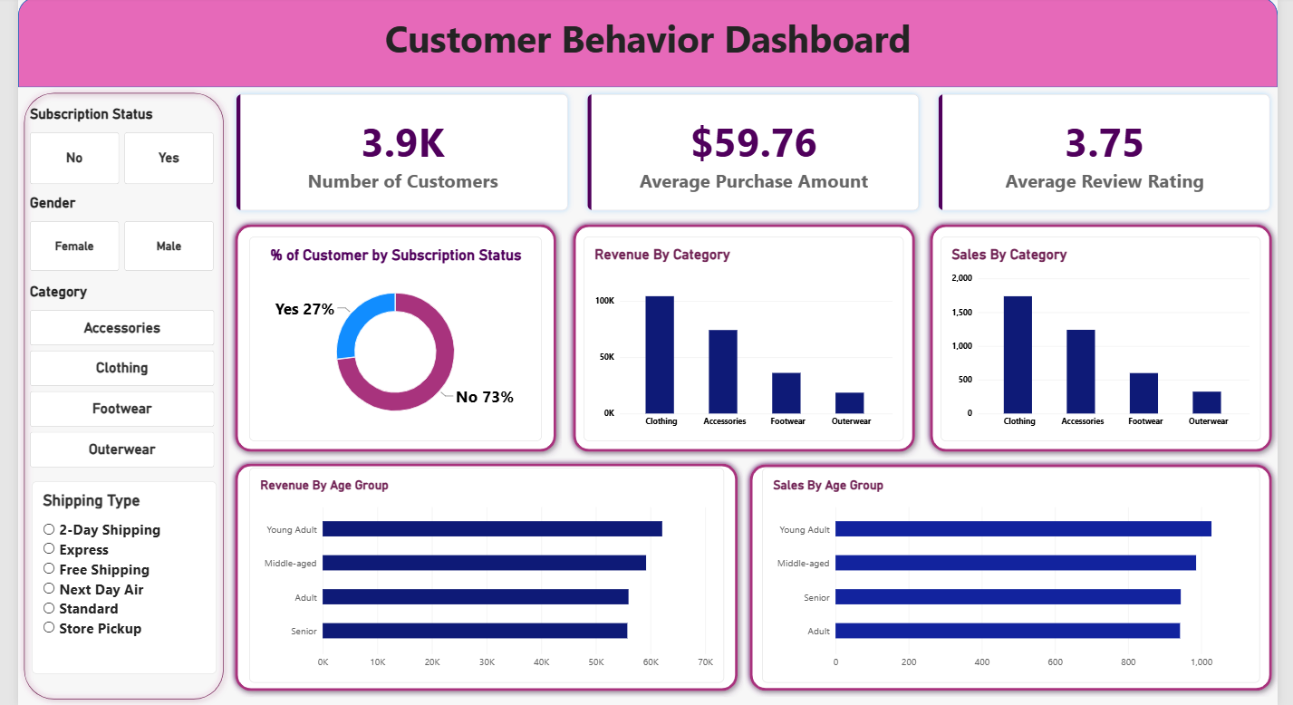
- KPI cards: Number of Customers, Average Purchase Amount, Average Review Rating.
- Subscription donut: Customer count by subscription status.
- Category charts: Sales (customer count) and Revenue by category.
- Age-group charts: Sales and Revenue by age group.
- Slicers: Gender, Subscription Status, Category and Shipping Type, which filter every visual on the page.
The category view shows where revenue concentrates: Clothing leads with $104,264 (44.7%), then Accessories $74,200 (31.8%), Footwear $36,093 (15.5%) and Outerwear $18,524 (7.9%). Because the slicers cut across all visuals, the dashboard lets a viewer reproduce the SQL findings above (for example gender or subscription splits) interactively.

5. Key Takeaways
- Clothing and Accessories drive about 77% of revenue. Outerwear is the smallest category.
- Spend per purchase is remarkably uniform across gender, age group, subscription status and shipping type, all within roughly $58–$61. Volume of customers, not basket size, explains most revenue differences.
- Subscriptions are not yet adding value. Subscribers spend slightly less per purchase, and repeat buyers are no more likely to subscribe. A subscriber-benefit or targeted conversion campaign could be tested.
- Discounts are heavily used (43% of purchases), and half of discount users still spend above average, so discount depth could be reviewed for margin.
- The base is mostly loyal (80%), so retention is strong but new-customer acquisition looks thin (2% new).

